System Design Proposal of Software to Support Operation of a Humanoid Robot in a Guitar Workshop

[c. 994 words]

# Introduction

This document presents the design proposal for some software in the operation of a humanoid robot in a guitar workshop environment (working on similar instruments as well), following object-oriented programming principles. This design is to support three fundamental operations that this robot might perform in a workshop setting:

1. **Navigation**: move through an environment and avoid obstacles
2. **Item Handling**: grab, move and place instrument components, such as bodies, necks and required hardware
3. **Assembly:** putting components together in a specific sequence, as needed, to produce completed instruments

These operations leverage the humanoid form of the robot, using articulated arms with grippers for handling and item manipulation, mechanical legs for movement, and camera sensors to determine its position and detect obstacles. This system is conceptually modelled with classes, attributes and methods and allows for simulated testing in a controlled environment.

Research shows that humanoid robots are increasingly designed for collaboration in industrial and workshop settings, moving safely, manipulating objects and interacting with human operators (Mukherjee et al, 2023); this supports the inclusion of the core operations outlined above, as these would be key challenges in the workshop context. Ackerman (2024) notes that the most valuable trait in humanoid robots is their functionality in human-centric environments, and not necessarily their aesthetics – though some (Mulko, 2023) note the advancements of making them more human in appearance, many studies, including a meta-analysis by Mara, Appel and Gnambs (2022), highlights that appearance is less important than industrial contexts, where performance and reliability take precedence. Even merely the fact that the “uncanny valley” effect from hyperrealism can be disturbing for operators (Mara et al, 2022; Peterson, 2025), provides further justification for prioritising function over appearance in this design.

Search terms:  
*“humanoid robots industrial applications”, “robot object manipulation”, robot assembly tasks”, “robot gripper manipulation”, “collaborative robots in workshops”*

# System Design

This design focuses on three core operations: navigation, item handling and assembly. Together, these operations allow the robot to move safely through its surroundings, manipulate objects and assemble instruments in a defined order. (See Class Diagram for attributes and methods, and Data structure justification for relevant data structures.)

1. **Navigation**

The robot should be able to move from one location to another, avoid obstacles, and follow waypoints.

1. **Item Handling**

The robot should be able to pick up and place instrument components with its arms and grippers.

1. **Assembly**

Once it has the relevant components, the robot should assemble the instrument following a defined sequence. Each step depends on the correct components and proper handling.

## UML Models

This section presents UML diagrams to visualise and clarify the interactions and structure of this system. The models show how the robot transitions between states, performs its core operations and uses data structures to achieve its functionality.

### Activity Diagram

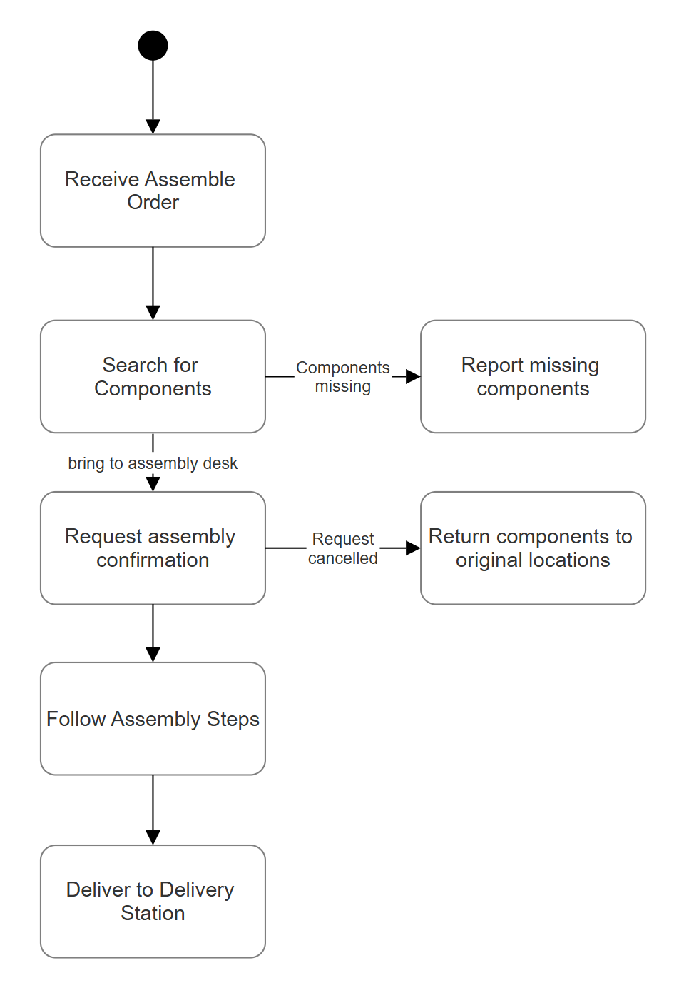

### Class Diagram

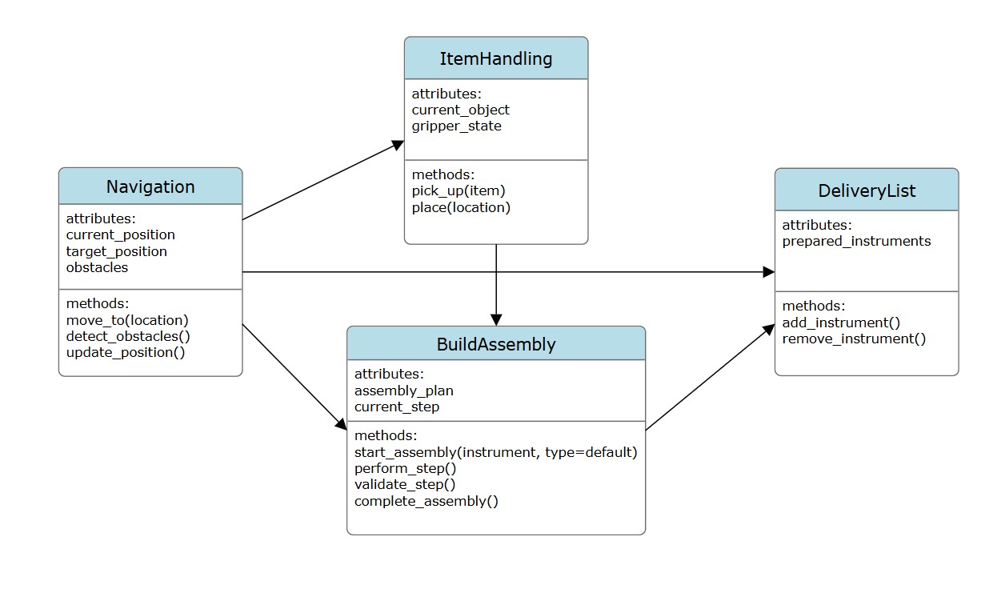

### Sequence Diagram

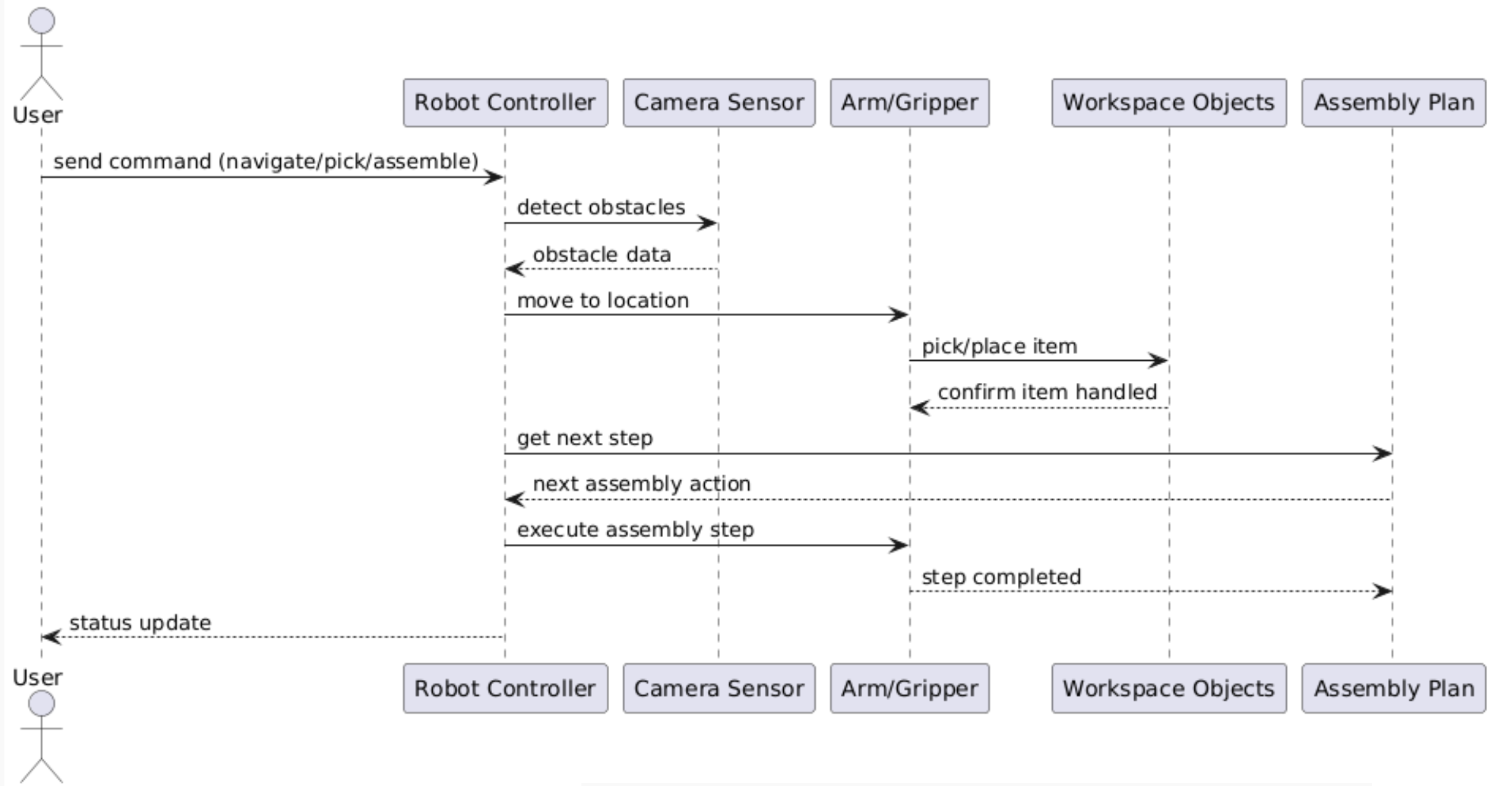

### Stage Transition Diagram

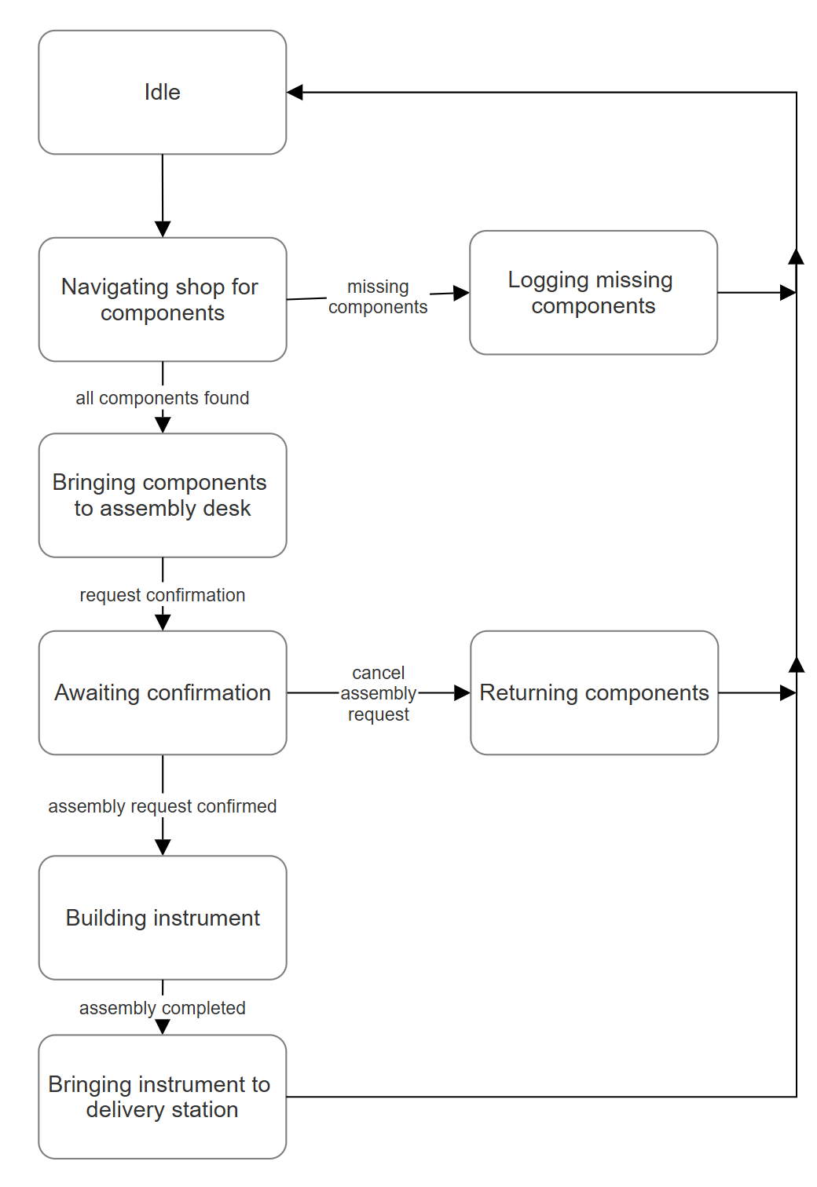

# Rationale

[c. 464 words]

## Operations choice

The three operations chosen – navigation, item handling and assembly – leverage the robot’s humanoid design. Navigation is essential for moving through a workspace adapting to changes in the environment. Item handling involves manipulating physical components such as guitar necks, bodies and other hardware, by gripping and placing them as needed. The assembly operation follows neatly: it requires the robot to follow a list of instructions to put the collected components together to form the complete instrument. Together, these three operations reflect a realistic workflow for what a robot working in such a space would be required to do.

## Object-oriented design specification

An object-oriented approach allows us to decompose the robot’s core functionality into modular classes interacting with each other. Navigation can be represented as a class with the attributes current_position and target_position, and with the methods detect_obstacles(), update_position() and move_to(). Similarly, item handling becomes a class with attributes for the gripper state and the currently held item, and with methods to pick up and place said items. The assembly process as its own class also comes with methods to load templates and follow their steps in order. This modularity allows each operation to be tested, refined or extended without having to rewrite the entire system, an advantage of object-oriented design (Bruege and Dutoit, 2010).

## Data structure justification

Each operation is supported by appropriate data structures (GeeksForGeeks, 2022):

* **Navigation**: Waypoints are processed first-in-first-out (FIFO) so that the robot moves through a sequence of paths in the order it receives them; a **queue** structure is ideal.
* **Item Handling:** A **stack** offers the needed last-in-first-out (LIFO) functionality for undo/redo-actions. A **list** can be used to contain components awaiting manipulation, because the order of access is flexible.
* **Assembly**: The assembly steps for each instrument are stored in a **queue**, as following the instructions in order is also a FIFO process; each step can be dequeued when executed.

Also, the delivery desk - where completed instruments are placed - is represented in the program as a **list**, as any instrument in the list can be removed (to ship off, for example) by the user; the stricter orders of queues and stacks are too limiting.

## Human-robot interaction considerations

This program makes use of a command-line interface. Providing an unambiguous means of talking to the robot during the design and testing phases, which in turn ensures commands are explicit and can be easily logged. To make this more visually informative, the system will likely also include a graphical representation of the robot’s workspace and extra information regarding what the robot is holding and what step in an assembly plan it is in. This could be implemented with a tool like jupyturtle in Python and likely placed in a class of its own, in accordance with object-oriented programming.

# Conclusion

This design demonstrates a structured approach to enabling a humanoid robot to operate affectively in an instrument workshop. By focusing on three core operations, the system models key humanoid capabilities – movement, manipulation and task execution – along with some error recovery. Overall, the design balances autonomy with oversight, providing a solid foundation for simulation and potential future development.

# References

Ackerman, E. (2023) *Humanoid Robots Are Getting to Work*. IEEE Spectrum. Available at: <https://spectrum.ieee.org/humanoid-robots> [Accessed: 10 September 2025].  
Bruege, B., Dutoit, A.H. (2010) *Object-Oriented Software Engineering Using UML, Patterns and Java*. 3rd Edition. Pearson Education. Available at: <https://uim.fei.stuba.sk/wp-content/uploads/2018/02/Object-oriented-Software-Engineering-3rd-Edition.pdf> [Accessed: 10 September 2025].  
GeeksForGeeks (2022) *Stacks and Queues in Python*. Available at: <https://www.geeksforgeeks.org/python/stack-and-queues-in-python/> [Accessed: 12 September 2025].  
Mara, M., Appel, M., Gnambs, T. (2022) *Human-Like Robots and the Uncanny Valley: A Meta-Analysis of User Responses Based on the Godspeed Scales*. Zeitschrift für Psychologie, 230(1), pp. 33-46. Available at: <https://doi.org/10.1027/2151-2604/a000486>  
Mukherjee, D. et al. (2022) *A Survey of Robot Learning Strategies for Human-Robot Collaboration in Industrial Settings*. Robotics and Computer-Integrated Manufacturing, 73, p.102231. Available at: <https://doi.org/10.1016/j.rcim.2021.102231>  
Mulko, M. (2023) *5 of the world's most realistic humanoid robots ever*. Interesting Engineering. Available at: <https://interestingengineering.com/lists/5-worlds-realistic-humanoid-robots> [Accessed: 13 September 2025].  
Peterson, M. (2025) *The Uncanny Valley And Designing Trust in Human-Robot Interaction*. iMotions. Available at: <https://imotions.com/blog/insights/thought-leadership/the-uncanny-valley> [Accessed: 15 September 2025].  
Zhu, S., Wang, H., Zhang, X., He, X. & Tan, Z., 2022. *A decision model on human-robot collaborative routing for collaborative order picking systems*. Procedia CIRP, 108, pp.225–230. Available at: <https://www.sciencedirect.com/science/article/pii/S1474034622001410> [Accessed 15 September 2025].